Guidelines for Implementing Partners

USAID/Latin American and Caribbean Bureau (LAC) ENVIRONMENTAL MITIGATION and MONITORING PLAN (EMMP)
November 19, 2015

A. Background

Definitions
Activity - Overall USAID action being undertaken through a particular implementing mechanism
Intervention - Discrete actions undertaken to accomplish activity goals
Component - A sub action required to complete an intervention

All activities funded by USAID must conform to its environmental procedures outlined in 22 CFR 216, which require Initial Environmental Evaluations (IEE) to ensure that “environmental factors and values are integrated into the USAID decision-making process” and that “the environmental consequences of USAID-financed activities are identified and considered by USAID and the host country prior to a final decision to proceed and that appropriated environmental safeguards are adopted”.

All USAID activities funded through USAID’s Latin America and the Caribbean (LAC) Missions are issued an Environmental Threshold Decision (ETD) by the Bureau Environmental Officer (BEO) pursuant to the IEE as per 22 CFR 216.3(a) 2. One category of Threshold Decision is the Negative Determination (22 CFR 216.3(a) 3, which is given to projects that are not ”found to have a significant effect on the environment” when certain conditions are in place. In LAC, the development of an Environmental Mitigation and Monitoring Plan (EMMP) is often one of the conditions set forth in the Negative Determination with Conditions (NDWC) ETD. The EMMP ensures compliance with 22 CFR 216 by identifying and mitigating environmental effects of USAID activities and by meeting any other conditions specified in the applicable ETD. It is also used for any sub-award interventions where the specific actions of sub-award are not yet identified at the time of award. In addition, Table 3 of the EMMP form can be used as a Mitigation and Monitoring Plan for Environmental Assessments (EA).

Activities carried out by implementing partners (IPs) of USAID/LAC Missions include a range of discrete interventions under various awards that will likely have a risk for significant environment effects. Examples include interventions such as infrastructure refurbishment or medical waste management. This EMMP procedure will provide for both the screening for environmental risk, the preparation of a mitigation plan and reporting on monitoring of these mitigation measures. Gender and persons with disabilities are also considered as social impact factors in the development of a mitigation plan as these have a direct bearing on the type and kind of mitigation measure to be prescribed. Global Climate Change (GCC) and its impact on the project, as well as the project’s to exacerbate GCC is also a consideration within the EMMP process. Finally, the EMMP is an effective tool for applying USAID’s Sector Environmental Guidelines to an activity or program which has been developed as per 22 CFR 216.3(a)3(iii). (http://www.usaidgems.org/sectorguidelines.htm).

The EMMP initially categorizes interventions into three risk categories: No Risk, Medium Risk, and High Risk. Those with No Risk can continue without further review upon completion of the Table 1 screening form and review and approval of the risk analysis by the Agreement/Contract Officer’s Representative (AOR/COR) and the Mission Environment Officer (MEO). The EMMP typically deals with those interventions at Medium Risk (see Figure 2). Those with High Risk must be reconsidered for the need of an EA. Risk is further defined in section C1 below.

Most awardees that receive a Negative Determination with Conditions ETD will be required to fill out an Environmental Mitigation and Monitoring Plan (as attached) per intervention type that includes:

- Narrative (Justification/Background, Baseline Information/Existing Conditions, Description of Activities, and Social Considerations sections must be completed at a minimum).

- The Environmental Screening Form (Table 1),

- The Environmental Mitigation Plan (Table 2), and

4. The Environmental Monitoring Table (Table 3).

AOR/CORs, Activity Managers, and Implementing Partners can work with the USAID MEO to ensure that environmental effects are sufficiently identified and mitigation actions are agreed upon, including clear guidance on the procedures for GCC and social considerations, where and appropriate.

B. Timing of EMMP

All solicitations for activities that fall within the NWDC will include this document as part of the solicitation package as per the ADS 204 annex regarding solicitation language. As per direction outlined here and in the Environmental Considerations section of all solicitation, potential applicants must present a draft EMMP with their submission. This is important, as the funding for mitigation implementation identified in Table 3 must be incorporated in the applicant’s proposal budget. The draft EMMP can also serve as a criterion for selection by the Technical Evaluation Committee reviewing proposals.

Once the Implementing Partner (IP) is chosen, the applicant submits a revised initial EMMP or contractor to the AOR/COR at the time the initial work plan is submitted. The MEO, and the Regional Environmental Advisor (REA) must approve this EMMP before work can commence. For sub-awards, the awardee is required to fill out the EMMP and submit it for approval to the Chief of Party (COP). The COP then submits the EMMP for review and final approval to the AOR/COR and MEO. Implementation of interventions shall not occur until final approvals of the EMMPs are received.

A format for this initial EMMP can be seen in attachment 1; it includes:

- An initial screening process using the “Environmental Screening Form” (Appendix 1, Table 1) to assure the intervention is at the Medium Risk Level.

- The identification of potential impacts and related mitigation measures using the “Environmental Mitigation Plan” (Appendix 1, Table 2) for each component of the intervention.

- The Environmental Monitoring Table (Appendix 1, Table 3) includes the necessary mitigation measures to be monitored, the monitoring indicators, who will conduct the monitoring, and when will the monitoring occur. Table 3 also includes a monitoring chart that documents who conducted the monitoring and the effectiveness of the mitigation measures.

At the end of each year of implementation, the EMMP is resubmitted with the same information as provided initially, along with a report reflecting the status of implementation and effectiveness monitoring of the identified mitigation measures using the “Environmental Monitoring Table” (Appendix 1, Table 3). This serves as the Annual Environmental Compliance Report (ECR) required by most implementing mechanisms. The ECR can be part of the annual Report required for the overall Activity as per the award requirements.

Results from the ECR are subsequently incorporated into a revised EMMP that shall be submitted to the AOR/COR for approval by the MEO/REA that reflects any new interventions in the activity’s second year work plan along with any changes to mitigation measures based on the prior year’s monitoring. This process of submitting the EMMP monitoring report at the end of the year, together with a revised EMMP that reflects the following year’s work plan, is repeated each year until the close of the activity (See Figure 1).

C. Initial Environmental Mitigation and Monitoring Plan

1. Classification of Level of Risk

Different interventions under an award can have varying levels of risk for environmental effects and therefore require different courses of action (Figure 2). No-risk interventions, classified under “a” below, do not require the development of an Environmental Mitigation Plan (Table 2) or an Environmental Monitoring Table (Table 3) and could be covered under a Categorical Exclusion (22 CFR 216.2(c)). The AOR/COR should consult with the MEO to determine if the action in question has already received Categorical Exclusion or if one must be requested from the BEO. Interventions identified as Medium-risk (“b”) require the IP to screen those potential environmental effects and develop a plan to mitigate them. High-risk interventions (“c”) include interventions that have irrevocable change and/or cannot be mitigated by the implementation of industry standards, best management practices, or design specific implementation standards and, therefore, are considered to have significant environmental effects that will require an EA (22 CFR216.2 (d)).

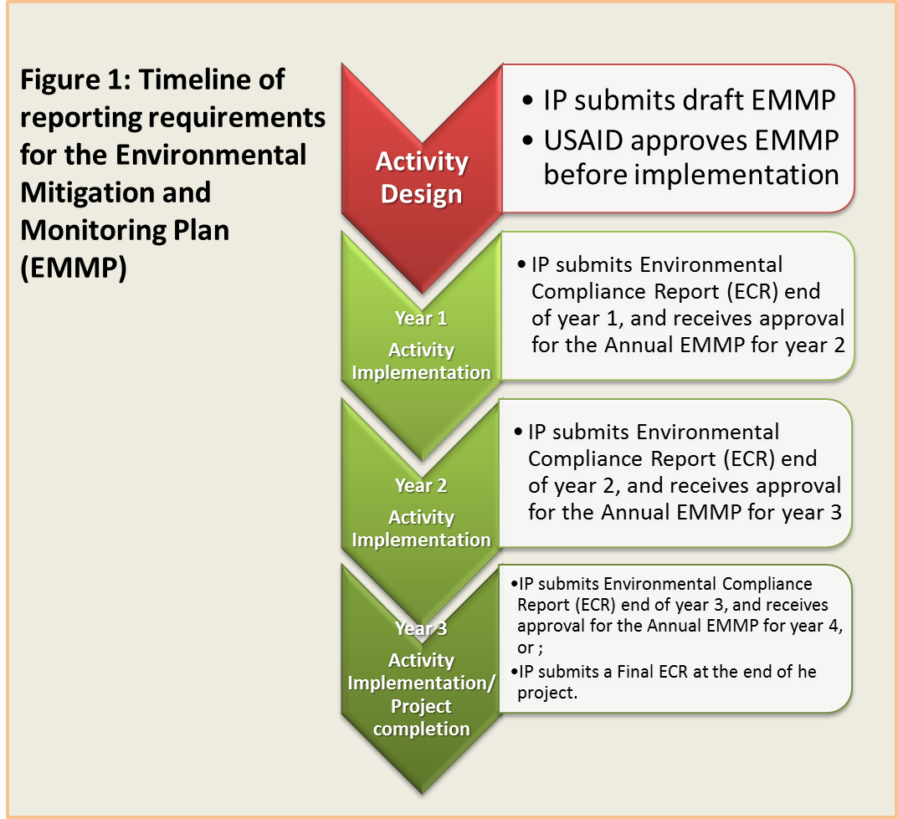

Figure 2 below depicts schematic of required action based on the level of risk of a particular intervention under an award. Note: all sub-award interventions are required to have an EMMP completed. If all questions on Table 1 are checked No, then the sub-award intervention falls under the low risk category and implementation could start directly without further analysis, pending approval of the work plan by the AOR/COR and MEO.

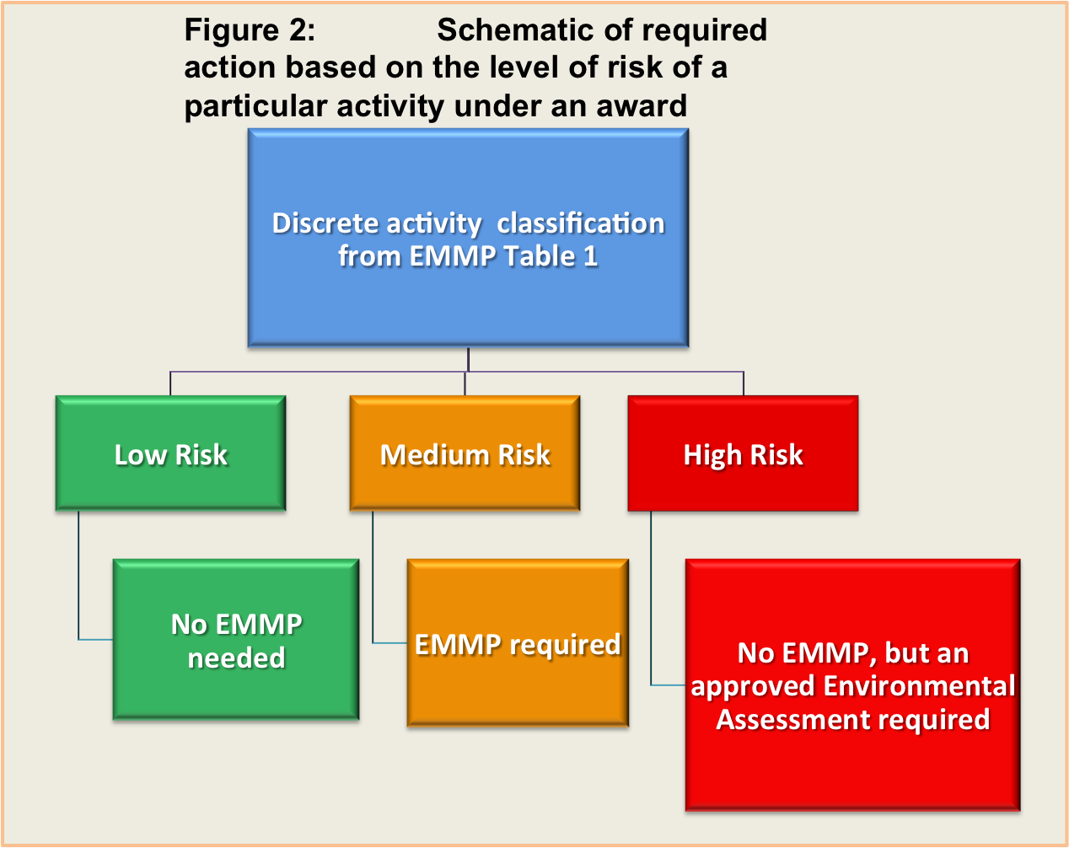

a) Discrete interventions that do not require mitigation plans (No-Risk):

An illustrative list of no-risk discrete intervention where no mitigation reporting is required includes:

- Education or training, unless it implements or leads to implementation of actions that impacts the environment (such as construction of schools or use of pesticides)
- Community awareness initiatives
- Controlled research/demonstration activities in a small area
- Technical studies or assistance (unless actions include agriculture and pesticides)
- Information transfers

If there is a risk that the actual implementation of subjects learned during training could adversely affects the environment (e.g., training on agricultural techniques), the training is expected to include as part of its curriculum, an analysis of environmental effects a plan for mitigation. Mitigation measures such as Good Agricultural Practices/Best Management Practices would need to be identified for use in training as a mitigation measure and listed in Table 2 of the EMMP.

Many discrete interventions under an agreement will fall between the two extremes of low and high risk and may cause some significant environmental effects that can be avoided or mitigated with proper planning. For these interventions, the IP will be responsible for completing the EMMP on an annual basis.

b) Discrete interventions that cannot be supported (High-Risk):

Under USAID’s Environmental Procedures, if there is a proposed action that may have significant environmental effects, an approved EA is required prior to its implementation (22 CFR 216.2(d)1). In the case of pesticide use, a Pesticide Evaluation Report and Safer Use Action Plan (PERSUAP) will be prepared by the partner and approved by the LAC BEO (22 CFR 216.3 (b)). Such interventions include, but are not limited to:

- Agricultural, livestock introduction or other activities that involve forest conversion
- Resettlement of human populations
- Construction of water management systems such as dams or impoundments
- Drainage of wetlands
- Introduction of exotic plants or animals in protected areas
- Permanent modification of the habitat supporting an endangered species
- Industrial level plant production or processing (this does not include community or regional plant nurseries aimed at restoring areas after fires, for example)
- Installation of aquaculture systems in sensitive water bodies including rivers, lakes, and marine waters (not land-based fish ponds)
- Procurement of timber harvesting equipment, including chainsaws
- Use of restricted use pesticides (insecticides, herbicides, fungicides, etc.)
- Large-scale reconstruction in un-degraded lands, such as within protected areas
- Large-scale new construction (over 1,000 meters²)
- Timber harvesting, or cutting of trees over 20 cm diameter breast height related to forest management or for commercial products.
- Construction of penetration roads and/or reroutes

c) Cumulative Effects

Even though individual interventions may be considered medium risk, when those interventions are analyzed in terms of other USAID actions and/or other non-USAID actions that are likely to occur, cumulative effects must be considered and may require the development of an EA.

d) Extraordinary circumstances

Certain extraordinary circumstances must be considered and may require an EA. These include
- impacts to sensitive terrestrial or aquatic areas (see question 14)
- impacts to unique cultural or historical features (see question 28)

2. Environmental Screening Form

The Environmental Screening Form (Appendix 1, Table 1) contains information relevant to the potential environmental effects over the life of the intervention with regard to natural resources, the environment, and human health. If items in Column “A” of the Environmental Screening Form are checked “YES”, then items for monitoring and mitigation are to be specified in the “Environmental Mitigation Plan” (Appendix 1, Table 2). The Environmental Mitigation Plan simply outlines the plan of action for mitigation of potential environmental effects. If all Column A is checked “NO”, then Tables 2 and 3 are not required to be completed and the intervention can begin upon approval from the COR/AOR and MEO. When all of Table 1 questions are checked “NO”, the MEO must ensure that the intervention listed in the “Description of Activities” narrative section truly will not cause impacts to the environment. The MEO must also ensure that all of the actions for the intervention are listed in the Narrative and that each action is covered in Table 1.

For reference on mitigation information on a wide variety of discrete interventions, refer to the USAID/GEMS Sector Environmental Guidelines. http://www.usaidgems.org/sectorGuidelines.htm. Illustrative sector-specific guidelines also include: WHO guidelines for handling and disposal of medical waste, “Low-Volume Roads Engineering: Best Management Practices Field Guide (Keller and Sherar, 2003)” and the World Wildlife Fund Agriculture and the Environment, A WWF Handbook on Agricultural Impacts and Better Practices (Clay, 2004).

D. Annual Environmental Compliance Report

As per terms and conditions of all awards with USAID, each implementing partner is expected to submit an Annual Report, which normally requires an ECR. If an EMMP has been developed, it should be used to fulfill this requirement. The ECR should contain information relevant to the potential environmental effects over the life of a discrete intervention under an award and includes: a) a copy of the initial EMMP completed during the initial intervention planning (reference Section B above); b) the prescribed mitigation measures using the “Environmental Mitigation Plan (Appendix 1, Table 2)”; and c) synthesized data on these mitigation measures collected throughout the year and tracked in the “Environmental Monitoring Table (Appendix 1, Table 3)”. As it is often difficult to quantitatively measure progress of complex mitigation measures, it is necessary to include inserted digital photos (with relevant maps) to describe progress of mitigation measures.

E. Sections of the EMMP

- EMMP Coversheet
- EMMP Narrative (to be filled out with intervention specific information). NOTE: details for each of the actions to be implemented must be listed in the “Description of Activities” section of the Narrative.
- Appendices:
- Environmental Screening Form (Table 1)
- Environmental Mitigation Plan (Table 2)
- Environmental Monitoring Table (Table 3)
- Photos, Maps, Level of Effort

Reference: February 8, 2007; L. Poitevien (USAID/Haiti), M. Donald (USAID/Dominican Republic), E. Clesceri (USAID/Washington). Guidelines for Implementing Partners on the USAID Haiti Environmental Mitigation Report.

USAID/LAC ENVIRONMENTAL MITIGATION and MONITORING PLAN (EMMP)
A. Coversheet for ENVIRONMENTAL MITIGATION and MONITOR PLAN (EMMP)

USAID MISSION DO # and Title: __________________________________________

Title of IP Activity: ______________________________________________________

IP Name: _____________________________________________________________

Award Number: ________________________________________________________

Funding Period: FY______ - FY______

Associated IEE/ETD: _______________________________

Life of Activity Funding (US$): ___________________________

Title of Discrete Intervention _______________________________

Report Prepared by: Name:__________________________ Date: ____________

Date of Previous EMMP: ____________________________ (if any)

Status of Fulfilling Mitigation Measures and Monitoring:

Yes No
___ ___ Initial EMMP.

___ ___ Annual EMMP.

USAID Mission Clearance of EMMP for XXX Intervention:

Contract/Agreement Officer’s Representative: __________ Date: ______________

Mission Environmental Officer: ______________________ Date: ______________

Regional Environmental Advisor: ____________________ Date: ______________

B. Environmental Mitigation and Monitoring Plan Narrative

1. Background, Rationale and Outputs/Results Expected:

Provide a brief summary of the intervention(s) under consideration and expected results.

2. Environmental Baseline:

Describe the existing condition of the area of the intervention. This should include a description of/baseline information on the natural and physical resources that could potentially be affected by the intervention. Provide information on the existing infrastructure, roads, and agricultural systems, etc. if relevant to the intervention. Succinctly describe location, site details; surroundings (include a map, even a sketch map). Include information on any “unique or extra-ordinary” resources that are within the intervention area such as wetlands, critical habitat, etc. Include information on the existing climate trends and conditions such as how might environmental conditions change due to climate change for the life of the intervention and expected lifespan of the interventions? Describe how the intervention will involve men, women, and indigenous cultures whose actions during the life of the intervention may have a direct effect the environment, or how the actions of the intervention may have an impact on them. Methodologies for data collection and analysis for gender-sensitive implementation and monitoring of interventions are encouraged.

3. Activity Description/Specific Actions to be implemented:

Provide both quantitative and qualitative information about actions to be undertaken during the intervention (e.g. specific actions of construction-size, location, and type of materials to be used, etc.), types of agriculture production (full till mechanized, organic etc.), how the intervention will operate, and any connected interventions that are required to implement the primary interventions (e.g., road to a facility, need to quarry or excavate borrow material, need to lay utility pipes to connect with energy, water source or disposal point or any other intervention needed to accomplish the primary one but in a different location). If various alternatives have been considered and rejected because the proposed intervention is considered more environmentally sound, explain these.

Example:

New construction of a 900 square meter youth center located in XXX town and is 70 meters from the River XXX. Construction will be of block and cement with rebar reinforcing. Construction will include a new two-stall toilet and sinks using town water source from pipes. A 20 square meter biodigester will be used to capture waste and methane gas piped to the youth center kitchen for use as cook fuel. Biodigester will be underground and built of concrete by molds. Electrical wiring for the youth center will be installed with the power source by solar panels on the zinc roof and batteries/electrical circuits located attached to the center in a closed and locked storage room.

Interventions with sub-awards require a specific EMMP for each award.

4. Evaluation of the Potential for Environmental Effects (Tables 1 and 2):

As a component of conducting environmental screening and developing the Environmental Mitigation Plan (Appendix 1, Table 2), briefly summarize environmental effects that could occur before, during, and after implementation, as well as any problems that might arise with restoring or reusing the site, if the facility or intervention were completed or ceased to exist. Explain direct, indirect, and cumulative effects on various components of the environment (e.g., air, water, geology, soils, vegetation, wildlife, aquatic resources, historic, archaeological or other cultural resources, people and their communities, land use, traffic, waste disposal, water supply, energy, climate change adaptation, climate change mitigation, etc.). Indicate positive impacts and how the natural resources base will be sustainably improved.

For example, any intervention that increases human presence in an area, even temporarily, will increase noise, waste, and the potential for hunting, timber harvesting, etc.

5. Environmental Mitigation Actions (Tables 2 & 3):

For the Initial EMMP, summarize the mitigation measures in the “Environmental Mitigation Plan” (Table 2) and briefly describe how these measures will be monitored in the “Environmental Monitoring Table” (Table 3). Ensure that Table 3 includes the cost of implementing and monitoring each of the mitigation measures listed.

For the Annual EMMP, describe the effectiveness of mitigation measures based on monitoring. For example:

a) What mitigation measures have been put in place? How is the success of mitigation measures being determined (i.e., indicators)? Explain if and why the mitigation measures are not working or not effective? What adjustments need to be made?

b) What is being monitored, how frequently and where, and what action is being taken (as needed) based on the results of the monitoring?

6. Social Considerations

Gender equality is a USG-wide priority and USAID has, and will continue to a take a lead role in that effort. Integrating gender considerations into all stages of planning, programming, and implementation of development assistance is not only a legal mandate; it is an essential part of effective and sustainable development. The Automated Directive System (ADS) 201 sets out specific requirements to help ensure that appropriate consideration is given to gender as a factor in development planning at the Development Objective and the Intermediate Results level of Development Objectives all the way down to the interventions level. This programming policy includes clear guidance on the procedures for gender integration where determined to be appropriate.

Additionally, the USAID Disability Policy Paper (http://pdf.usaid.gov/pdf_docs/PDABQ631.pdf) sets out specific requirements to help ensure that appropriate consideration is given to persons with disabilities as a factor in development planning at the Development Objective and the Intermediate Results level of Development Objectives all the way down to the intervention level. Therefore, gender and persons with disabilities considerations are included in the EMMP checklist to ensure intervention implementation adheres to agency priorities and mandate. Additional information can be found at the following website: http://www.usaid.gov/sites/default/files/Guide_How_Integrate_Disability_Gender_Assessments_2010.pdf.
Impacts on indigenous cultures and their traditions should also be considered.

Ultimately, consideration of social issues helps avoid significant environmental effects (see 216.3 (a)(3)(iii)). Environmental mitigation measures should be specifically designed to take in account social issues such as gender and persons with disability, thus ensuring greater success of the mitigation measure and greater long-term sustainability of the intervention. The impacts and roles of women and children should be also taken into consideration when completing Table 2 regarding environmental (social) impacts and designing mitigation measures.

7. Climate Change Integration

Climate change impacts all areas of development and is often considered both a threat and a driver to many activities that USAID supports. Good climate change integration is part of good activity design. In addition, Executive Order 13677: “Climate-Resilient International Development” encourages integration of the Agency's GCC Initiative (GCC) of mitigation and adaptation principles throughout its portfolios. Therefore, GCC impacts (to the intervention and from the intervention implementation) shall also be considered. Actions that would minimize GCC impacts shall be included in the list of mitigation measures to be implemented.

Appendix 1. Environmental Screening Form (Table 1)

Name of intervention:________________________________________________  Implementing Partner: ___________________________________________  Award Number: ________________________________________________  Date:_________________________________________________________  Relevant IEE/ETD#_____________________________________________ |  | Column A | Column B | Column C
 |  | Yes | No | If answered yes to Column. A. Is it a high risk or medium risk
 |  |  |  | High Risk | Medium-Risk
INFRASTRUCTURE (Buildings, roads, WASH, etc.)
1 | Will the intervention involve construction and/or reconstruction/rehabilitation of any type of building? For new construction, if less than 1,000 m2 = medium risk, if greater than 1,000 m2 = high risk.¹
2 | Will the intervention involve building penetrating roads, road rehabilitation and maintenance or other road related infrastructure (drainage, bridges, etc..)? If penetrating road construction/rerouting = high risk², if repair/rehabilitation (improving drainage, resurfacing of existing roads) = medium risk.
3 | Will the intervention involve construction or rehabilitation of water and sanitation infrastructure (irrigation systems, potable water, water harvesting, septic systems etc.). Potable water systems require testing for bacteria, arsenic and other heavy metals.
4 | Will the intervention involve construction or rehabilitation of any other infrastructure such as landfills, incinerators, energy infrastructure, etc.
5 | Will the infrastructure intervention cost more than US $500,000³? If YES, approval of a USAID Engineer is required as mitigation measures in Table 2. Additionally, compliance with FAA 611 is required (please consult with the mission legal advisor).
6 | Does the intervention require adherence to national building code or other national regulatory standard? Mitigation measures in Table 2.
7 | Does the intervention require local planning permissions (i.e. zoning, building permits, etc.)

BIOPHYSICAL
9 | Will the intervention involve changes in water quality (pollution, sedimentation, stagnation, salinization, temperature change, etc.)
10 | Will the intervention affect surface or groundwater quantity
11 | Will the intervention involve training and/or implementation of agricultural practices/production including animal husbandry?
12 | Will the intervention involve aquaculture systems?
13 | Will the intervention involve the use or disposal of hazardous materials (used engine oil, paint, varnish, lead-based products, fluorescent light bulbs/mercury, batteries, asbestos or other hazardous or special management waste)? Consider effects to both the biophysical environment and human health.
14 | Will the intervention involve implementation of timber management^{5,},extraction of forest products, clearing of forest cover, and/or conversion of forest land by cutting of trees >20cm diameter at base height (DBH)?
15 | Is the intervention in or near (within 50m⁶) any sensitive terrestrial or aquatic areas including protected areas, wetlands, critical wildlife habitat (including nesting areas), and threatened or endangered species?
16 | Will the interventions proposed generate airborne particulates (dust), liquids, or solids (i.e. discharge pollutants) or potentially violate local air standards?
17 | Will the intervention create objectionable odors?
18 | Will the intervention occur on steep slopes (greater than 15%)?
19 | Will the intervention contribute to erosion?
20 | Will the intervention change existing land use in the vicinity?
21 | Is the proposed intervention incompatible with land type (i.e., annual crops on steep slopes, infrastructure on poorly drained soils)?
22 | Will the intervention affect unique geologic or physical features?
23 | Will the intervention have potential effects to inhabitants, natural landscapes, or flora/fauna downstream from the intervention site?
24 | Will the intervention have a direct or indirect effect, or include actions with mangroves, coral reefs and other marine/coastal ecosystems?
GLOBAL CLIMATE CHANGE
25 | Are interventions or outcomes vulnerable to changes in the weather or climate such as changes in precipitation patterns, increased temperatures or sea level rise?
26 | Does the intervention exacerbate climate change vulnerabilities (i.e., drought, flooding, decrease water supply)?
27 | Will the intervention create greenhouse gas emissions from decomposing waste, burning of organic matter, or use of fossil fuels etc. (consider duration and scale)
SOCIO ECONOMIC
28 | Will the intervention contribute to displacement of people, housing or businesses?
29 | Will the intervention affect indigenous peoples and/or unique cultural or historical features?
30 | Will the intervention expose people or property to flooding?
ENVIRONMENT & HEALTH
31 | Will the intervention create conditions encouraging an increase in illness, diseases, or disease vectors (waterborne, STDs or other)?
32 | Will the intervention generate hazards or barriers for pedestrians, motorists or persons with disabilities?
33 | Will the intervention involve the use, storage, handling or disposal of syringes, gauzes, gloves and other biohazard medical waste?
34 | Will the intervention expose workers to occupational hazards?
35 | Will the intervention increase existing noise levels?
GENDER⁷
36 | Does the intervention inhibit the equal involvement of men and women?
37 | Do the intervention results disproportionately benefit/impact men and women?
OTHER
38 | Does the intervention/activity involve a sub-award component?⁸
39 | Is an operations and maintenance plan required? (for all type of infrastructure, equipment, road rehabilitation, or water and sanitation action = Yes)

RECOMMENDED ACTION (Check Appropriate Action): |  | (Check)
(a) | The intervention has no potential for significant effects on the environment. No further environmental review is required (Categorical Exclusion). No further action required.
(b) | The intervention includes mitigation measures and design criteria that if, applied will avoid a significant effect on the environment (Negative Determination with Conditions). EMMP Required.
(c) | The intervention has potentially substantial or significant adverse environmental effects; therefore, an EA is required before intervention implementation (Positive Determination). NOTE: if any question is marked as High Risk, an EA is required and Tables 2 and 3 of the EMMP do not need to be completed.
(d) | The intervention has significant adverse environmental effects that cannot be mitigated. Proposed mitigation is insufficient to eliminate these effects and alternatives are not feasible. The intervention is not recommended for implementation.  *For sub awards, do not fund.

¹Construction interventions need to be reviewed for scale, planned use, building code needs and maintenance. New construction having a footprint larger than 1000 meters² or 10,000 feet² is considered large scale and high risk. Some small construction interventions, such as building an entrance sign to a park, may require simple mitigation measures whereas larger buildings will require more extensive review and monitoring.
² New construction of roads are considered high risk and will require a full environmental assessment of the planned construction, i.e. a Positive Determination. Any reroutes of a road or trail longer than 100 meters is considered a high risk. Reroutes within a protected area, nearby a water source/wetlands, and/or archaeological site are considered a high risk.
³ Pursuant to FAA, section 611, Completion of Plans and Cost Estimates.
⁴The purchases of packaged store pesticides are included. The planned procurement and/or use or training on the use of pesticides will trigger the need to develop an amended Initial Environmental Examination that meets USAID pesticide procedures (Pesticide Evaluation Report and Safer Use Action Plan or “PERSUAP”) for the intervention.
⁵Any interventions that involve the commercial harvesting of trees or converting forests is considered high risk and will require a full environmental assessment of the intervention (i.e. Positive Determination). The reference to cutting trees of greater than 20cm dbh is for actions related to forest management and commercial forest products and not for individual trees being cut for construction or non-commercial purpose.
⁶ Less than 50meters is based on best practices from US Federal and State regulations.
⁷A positive response to gender questions require follow up only when there are other positive responses on questions, and an EMMP is developed.
⁸ If the intervention includes a sub-award component, each sub-awardee shall be required to prepare an EMMP prior to implementation of the sub-award.

Appendix 2. Environmental Mitigation Plan (Table 2)

Enter the Question/Row # of the potential negative effects with check marks in Column A (Table 1) and complete table below for mitigation measures to reduce or eliminate the issue. In the Sub-Activity or Component Column, list the main actions to be implemented. Under each action, list the tasks (Steps) that are needed to implement this action.

Name of intervention:___________________________________________
Implementing Partner: ______________________________________
Award Number: ____________________________________________
Date:____________________________________________________
Relevant IEE/ETD #_________________________________________
# of the question from Table 1 | Action or component with the different tasks required to implement the action. | Description of Environmental Effect | Environmental Mitigation Measures*
1 | Component - Construction and maintenance of latrine
 | Step 1- design
 | Step 2- location
 | Step 3- purchase of materials
 | Step 4- build latrine
 | Step 5- site cleanup/disposal of construction waste
 | Step 6- use of latrine/operations and maintenance
9 | Component – Purchase and construction of a water storage system
 | Step 1
 | Step 2
 | Step 3
 | etc.

* Please be as specific as possible. Sample mitigation measures are located in the USAID Sector Environmental Guidelines or other pertinent guidelines, see http://www.usaidgems.org/sectorGuidelines.htm. Details on exact monitoring plan are illustrated in Table 3, Environmental Monitoring and Evaluation Tracking Table.

Appendix 3. Environmental Monitoring Table (Table 3)

Award Number:
intervention Name:
Implementing Partner:
Location Name:
Nearby Communities:
Senior Activity Manager:
Monitoring Period:
Date:

 | Description of Mitigation Measure (same as in Table 2) | Responsible Party for implementing and monitoring mitigation measures | Monitoring Methods |  |  | Estimated Cost of implement-ing mitigation measures and monitoring | Results |  |  | Recommended Adjustments
 |  |  | Indicators of implemen- tation and effective- ness of indicators | Methods | Frequency |  | Dates  Monitored | Problems Encountered | Mitigation Effectiveness

This replaces all previous Environmental Mitigation Plan and Report (EMPR) forms

